0000
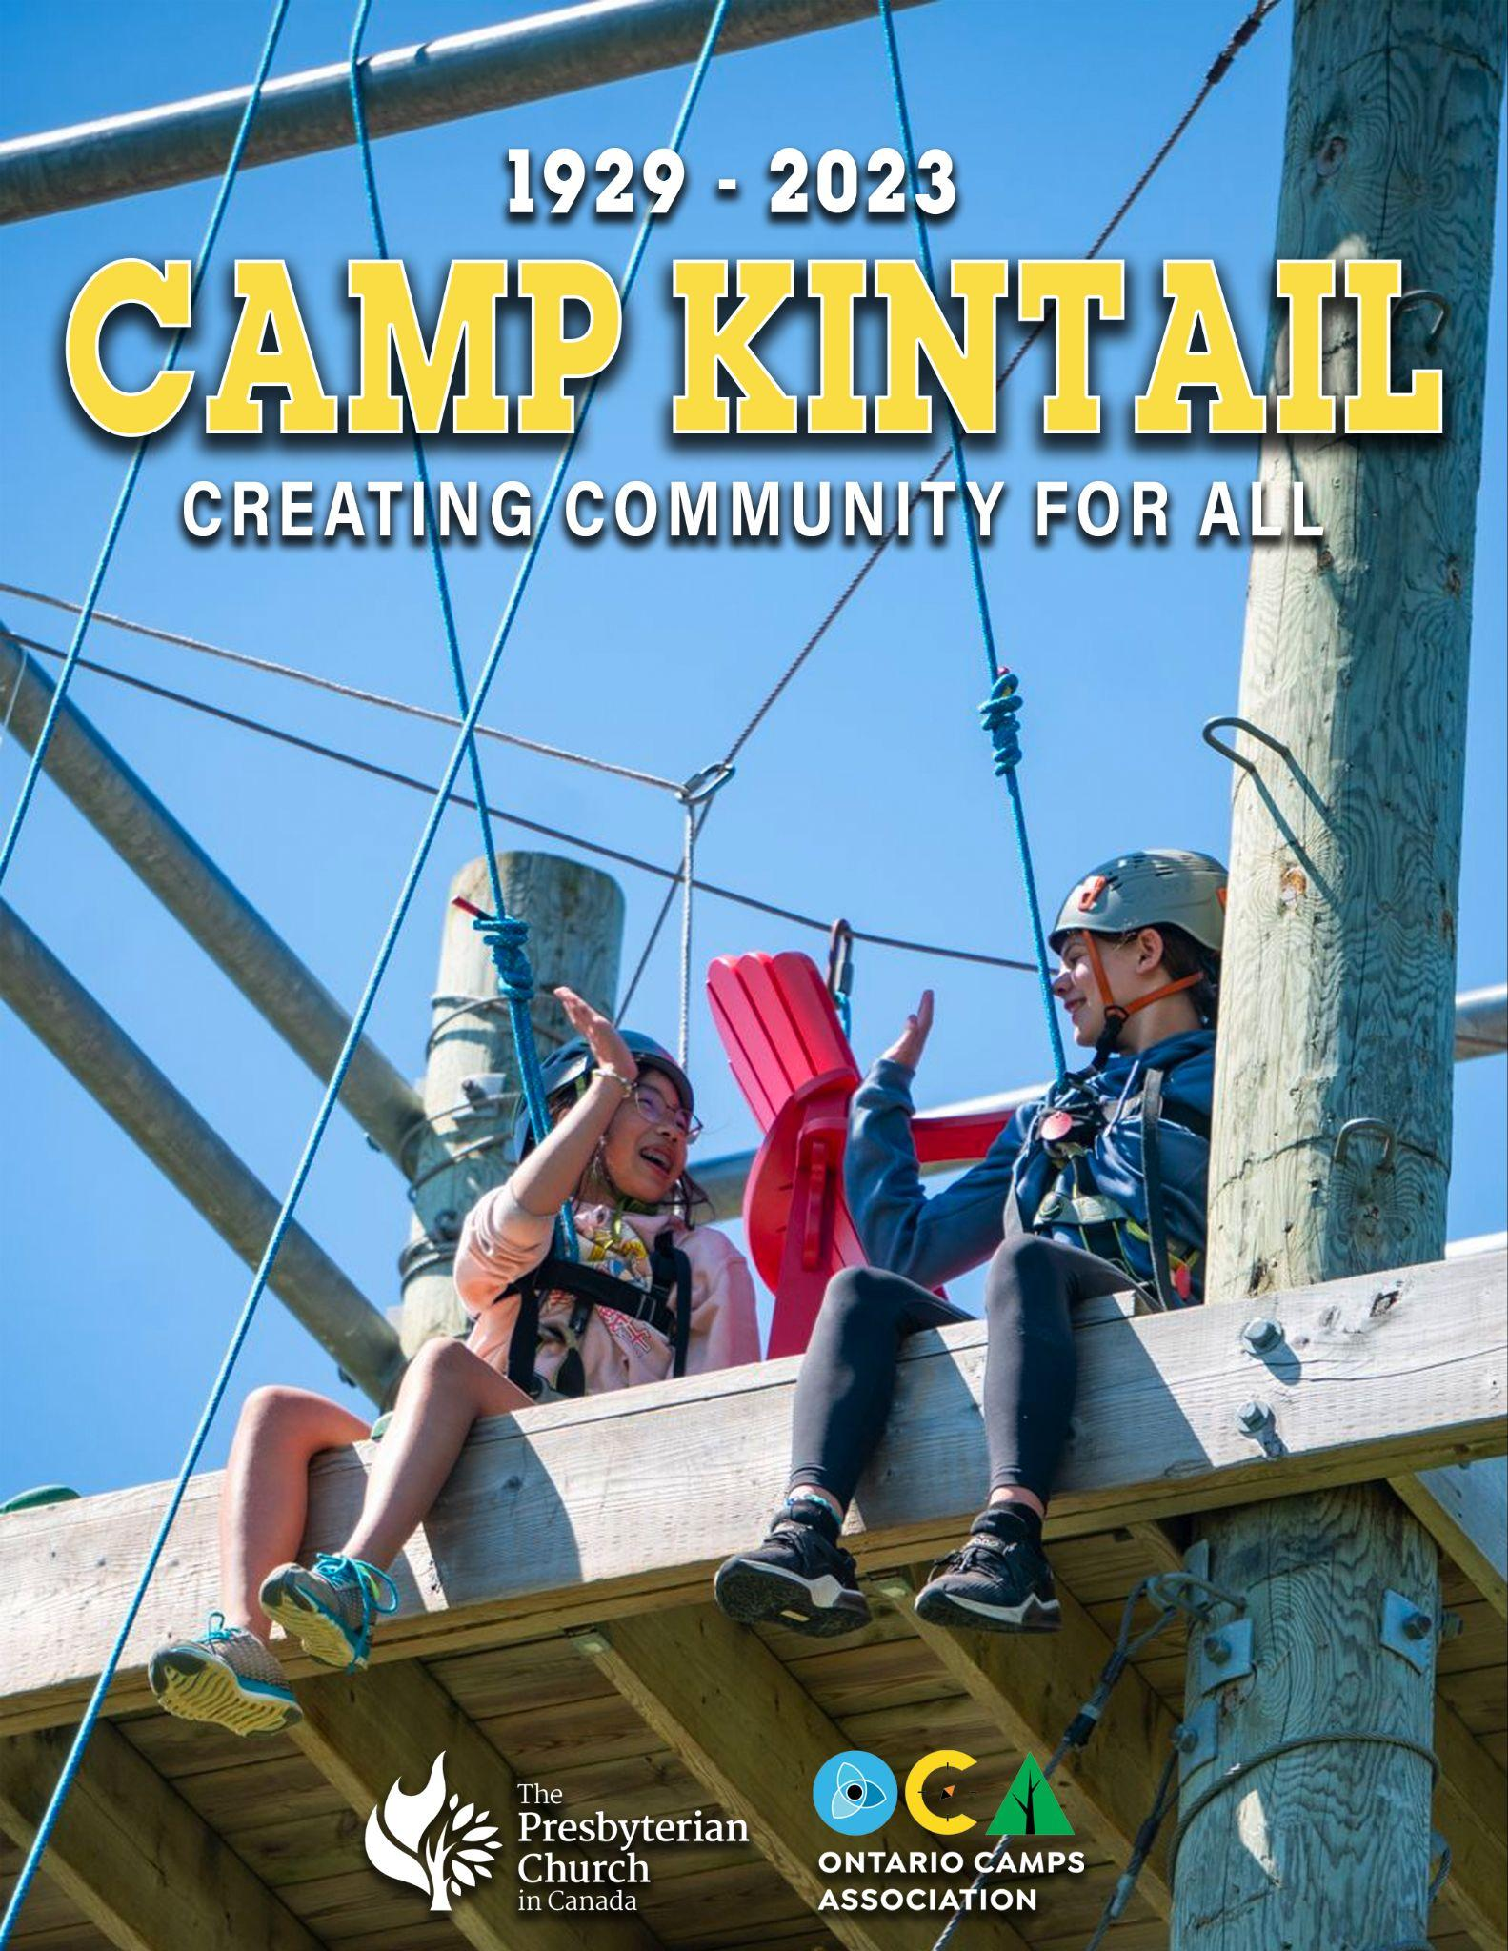
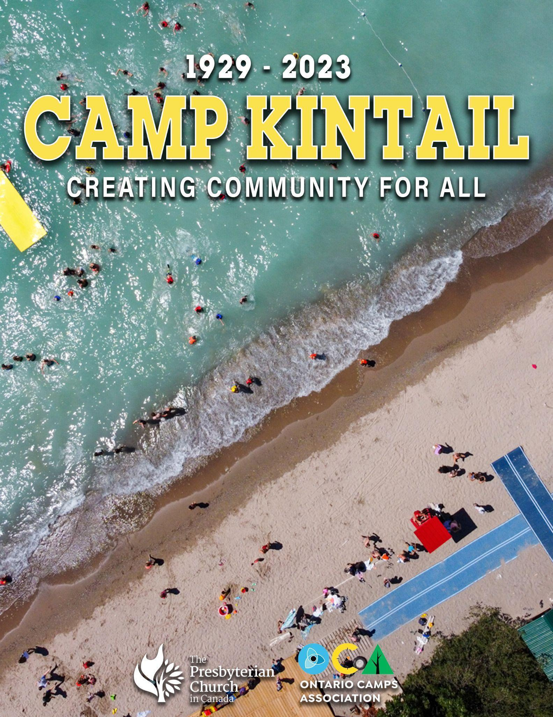
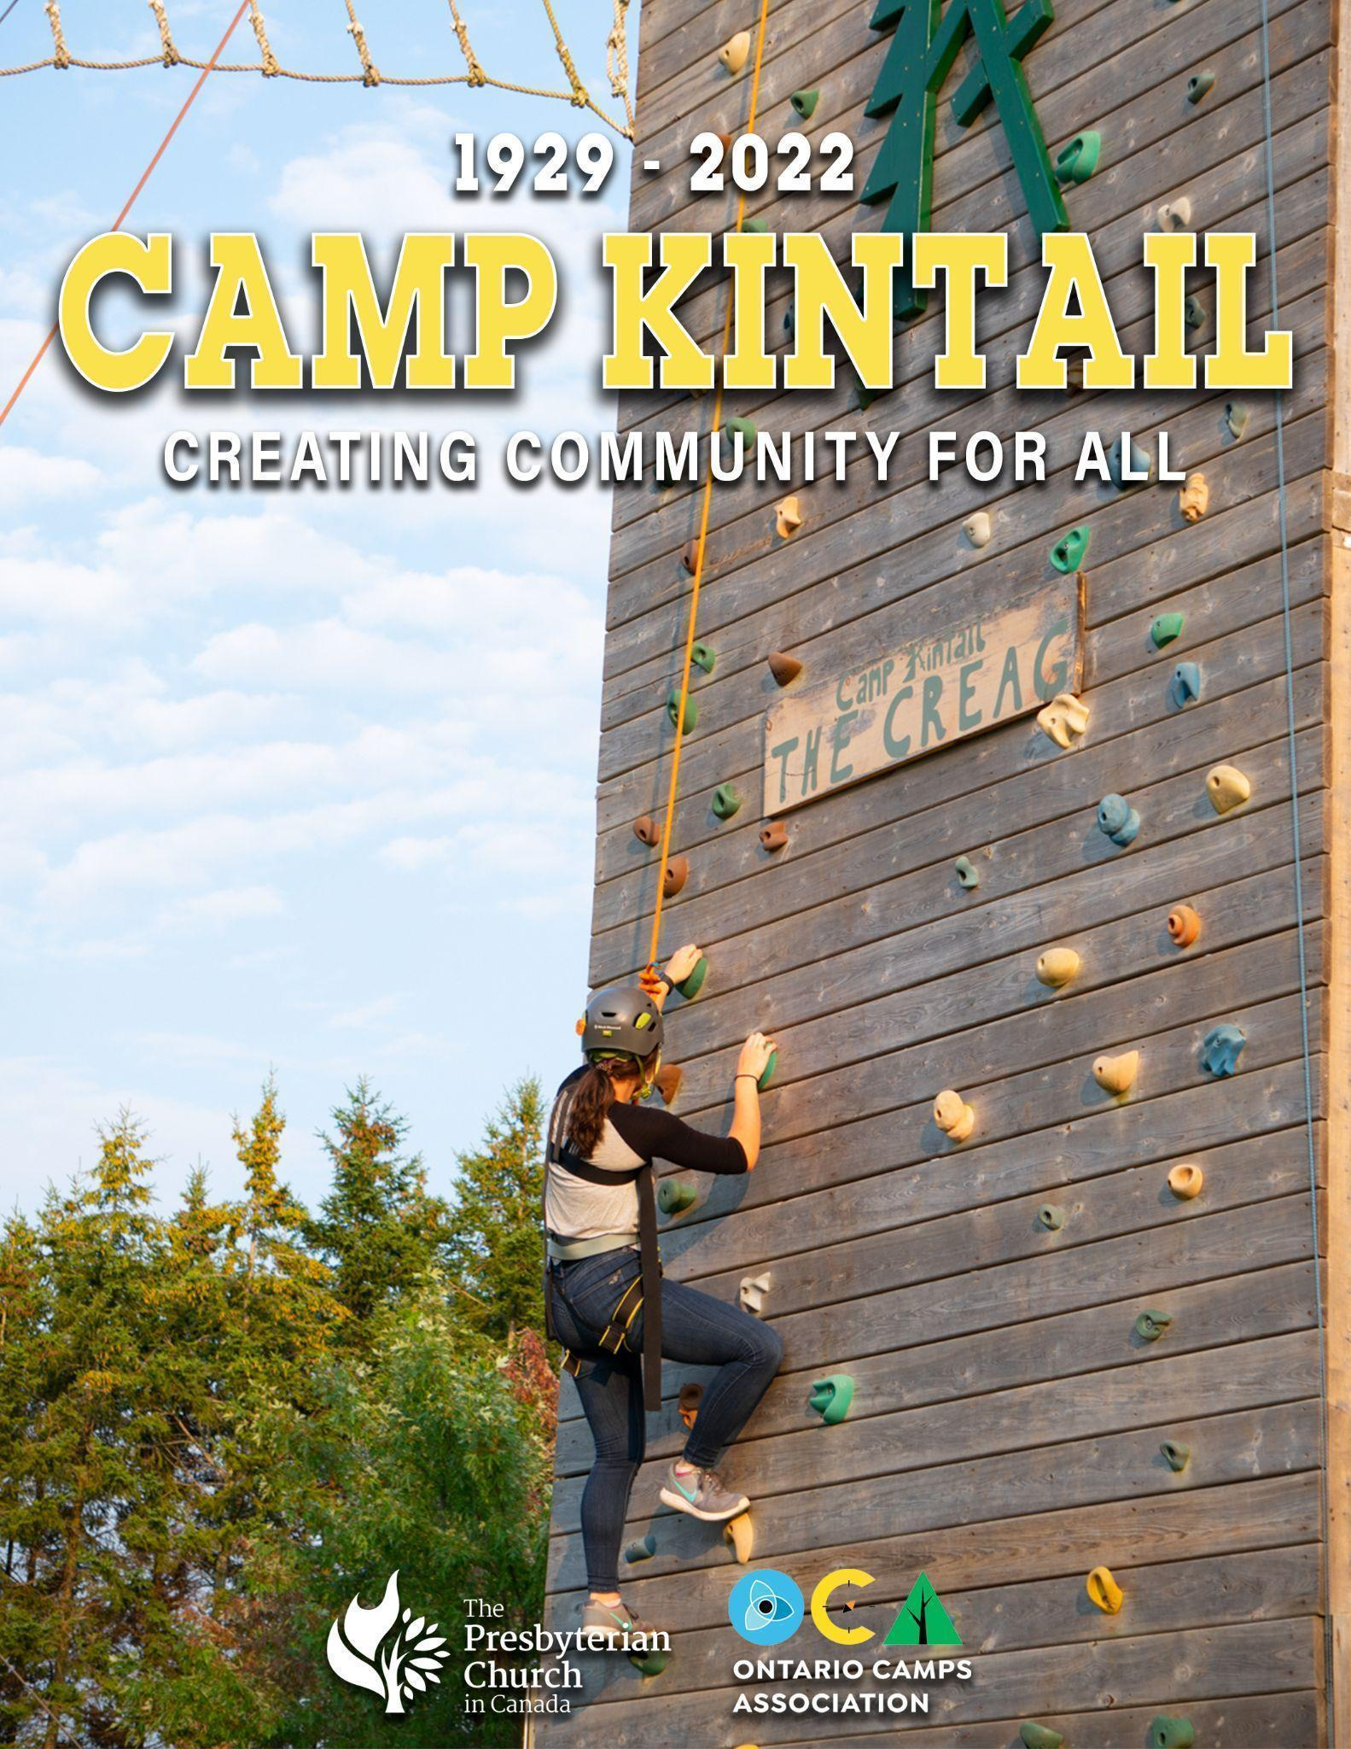
fsg

SUMMER SCHEDULE 2024
Code | Session Name | Ages | Cost *+HST for overnight stays
 |  |  | Option A | Option B | Option C
K1 – Sunday, July 2 – Friday, July 1-5
 | Day Camp | 5-13 | $300 | $340 | $380
K2 – Sunday, July 7 – Friday, July 12
LIT | K2-K3 LIT Leader in Training (Sunday July 9 - 21) | 16-17 | $1300 | $1400 | $1500
K2DIS | Jr. Discovery | 7-10 | $725 | $795 | $865
K2ODA | Int. Outdoor Adventure | 10-14 | $725 | $795 | $865
K2VOK | Volunteers of Kintail | 14-17 | $675 | $745 | $815
K2DAY | Day Camp (Monday -Friday) | 5-13 | $300 | $340 | $380
K3 – Sunday, July 14 – Friday, July 19
K3ODA | Jr. Outdoor Adventure | 7-10 | $725 | $795 | $865
K3DIS | Int. Discovery | 10-14 | $725 | $795 | $865
K3VOK | Volunteers of Kintail | 14-17 | $675 | $745 | $815
K3DAY | Day Camp (Monday -Friday) | 5-13 | $300 | $340 | $380
K4 – Sunday, July 21 – Friday July 26
K4DIS | Jr. Discovery | 7-10 | $725 | $795 | $865
K4INT | Int. Outdoor Adventure | 10-14 | $725 | $795 | $865
K4SODA | Senior Outdoor Adventure | 13-16 | $725 | $795 | $865
K4VOK | Volunteers of Kintail | 14-17 | $675 | $745 | $815
K4DAY | Day Camp (Monday -Friday) | 5-13 | $300 | $340 | $380
K5 – Sunday, July 28 – Wednesday, August 31
K5SPR | Sprouts Try-Out | 5-7 | $510 | $575 | $640
K5JRTD | Junior Discovery Try-Out | 7-10 | $510 | $575 | $640
K5INTO | Intermediate Outdoor Adventure Try-Out | 10-14 | $510 | $575 | $640
K5VOK | Volunteers of Kintail | 14-17 | $480 | $545 | $610
K6 – Friday, August 2 – Monday, August 5
K6FAM | Family Camp - Adult | 0-100 | See Week Away Prices
K7 –Tuesday, August 6 – Friday, August 9
K7JRTO | Junior Outdoor Adventure Try-Out | 7-10 | $510 | $575 | $640
K7INTD | Int. Discovery Try-Out | 10-14 | $510 | $575 | $640
K7VOK | Volunteers of Kintail | 14-17 | $480 | $545 | $610
K7DAY | Day Camp | 5-13 | $290 | $325 | $360
K8 – Sunday, August 11 – Friday, August 16
K8ODA | Jr. Outdoor Adventure | 7-10 | $725 | $795 | $865
K8DIS | Int. Discovery | 10-14 | $725 | $795 | $865
K8PLIT | Pre-Leader in Training | 14-16 | $725 | $795 | $865
K8VOK | Volunteers of Kintail | 14-17 | $675 | $745 | $815
K8DAY | Day Camp (Monday -Friday) | 5-13 | $300 | $340 | $380
K9 – Sunday, August 19– Friday, August 23
K9DAY | Day Camp (Monday -Friday) | 5-13 | $300 | $340 | $380
K10 – Monday, August 26 – Friday, August 30
K10DAY | Day Camp (Monday -Friday) | 5-13 | $300 | $340 | $380
KINTAIL RETREATS 2024
FWR | Women’s Retreat - February 9-11 | 16-99 | See Week Away Prices
SKCRC | Spring Craft Retreat - May 10-11 | 0-99 | See Week Away Prices
KAWAC | May Long Weekend Away Cabins Only - May 17-19 | 0-99 | See Week Away Prices
CAWA | Canada Day Weekend Away - June 28- June 31 | 0-99 | See Week Away Prices
NKCRN | Fall Craft Retreat - November 22-24 | 16-99 | See Week Away Prices
ADAWA | Advent Weekend Away - November 29-December 1 | 0-99 | See Week Away Prices

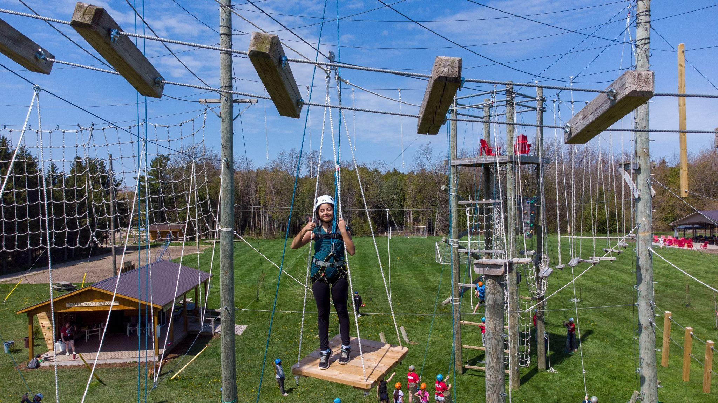
FLEXIBLE PRICING - CAMPS
Session | Option A | Option B | Option C
Overnight Camps
5 Night Overnight Camp  3 Night Try-Out/ Sprouts Camp | $675 +HST  $510 +HST | $740 +HST  $575 +HST | $805 +HST  $640 +HST
5 Night VOK Camps | $625 +HST | $690 +HST | $755 +HST
3 Night VOK Camps | $445 +HST | $510 +HST | $575 +HST
5 Day Day Camp | $300 | $340 | $380
3 Day Day Camp | $290 | $325 | $360
2 Week Leader in Training Program | $1300 +HST | $1400 +HST | $1500 +HST

Why three prices? The pricing option you select in no way affects your campers experience at Kintail. Every family can choose the level of payment that is right for their situation. Option A is the traditionally subsidized rate, Option C is the rate that is more representative of the true cost of camp, while Option B is the midpoint. These lower rates are made possible by donations from individuals and churches. Please choose the option that suits your needs best.

FLEXIBLE PRICING - RETREATS & FAMILY CAMP
Session | Option A | Option B | Option C
2 Night Weekend Away/ Retreat
Nest/Lodge-Adult  Nest/Lodge-Child  Cabin/Trailer-Adult  Cabin/Trailer-Child | $280 +HST  $225 +HST  $225 +HST  $185 +HST | $330 +HST  $275 +HST  $250 +HST  $225 +HST | $380 +HST  $325 +HST  $325 +HST  $275 +HST
3 Night Weekend Away/ Retreat
Nest/Lodge-Adult  Nest/Lodge-Child  Cabin/Trailer-Adult  Cabin/Trailer-Child | $390 +HST  $315 +HST  $315 +HST  $250 +HST | $440 +HST  $365 +HST  $360 +HST  $300 +HST | $490 +HST  $415 +HST  $410 +HST  $350 +HST

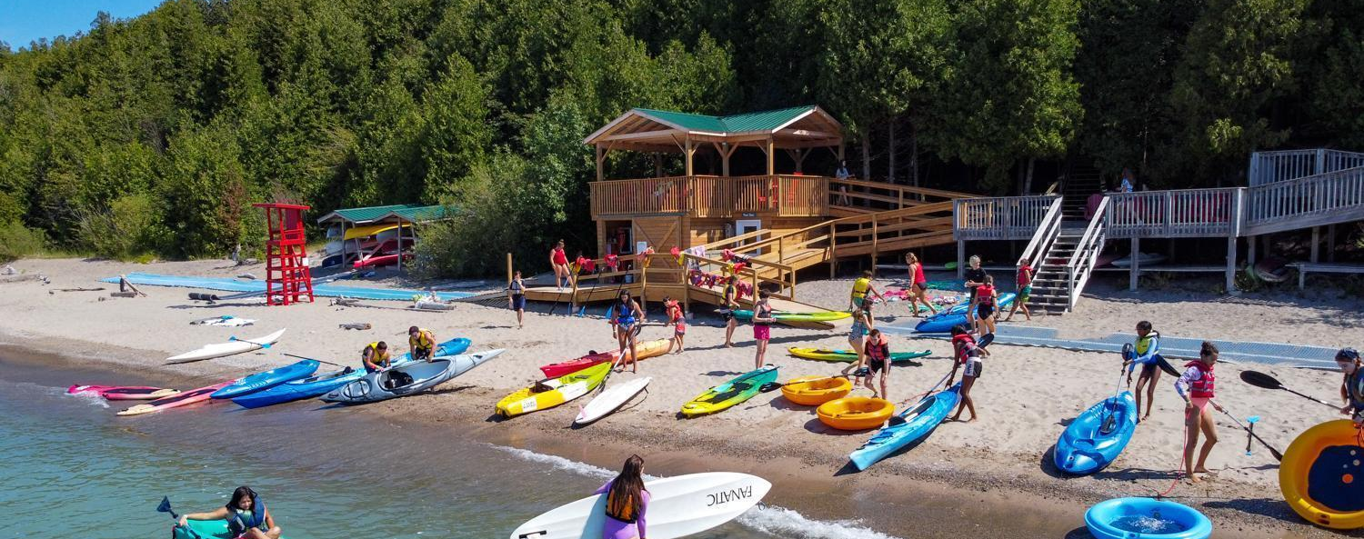

Why choose Camp Kintail?

Camp Kintail is the #1 choice for parents for many reasons!
- Well trained, responsible, caring, fun, and enthusiastic staff who love children
- Accreditation from the Ontario Camps Association
- Excellent food services, including healthy options that children love
- A faith-based community that welcomes all
- A lakefront setting with Lake Huron waves, and unforgettable sunsets
- Accessible site with great thought put into welcoming all campers and staff
- Unique activities that are safe and fun for all ages!

CAMP KINTAIL ACTIVITIES
High Challenge Course  Rock Wall (Age 7+)  Adventure Tower (Age 7+)  High Ropes (Age 9+)  Low Ropes (All ages)  Beach  Swimming in Lake Huron,  Campfire | Canoes  Kayaks  Paddleboards  Corcls  Aquamat  Outdoor Living Skills  Hiking Trail | Archery  Arts & Crafts  100ft. Slide  Slingshot Range  Disc Golf  Music & Drama  Cookout  Singing

*Zipline will not operate for 2024

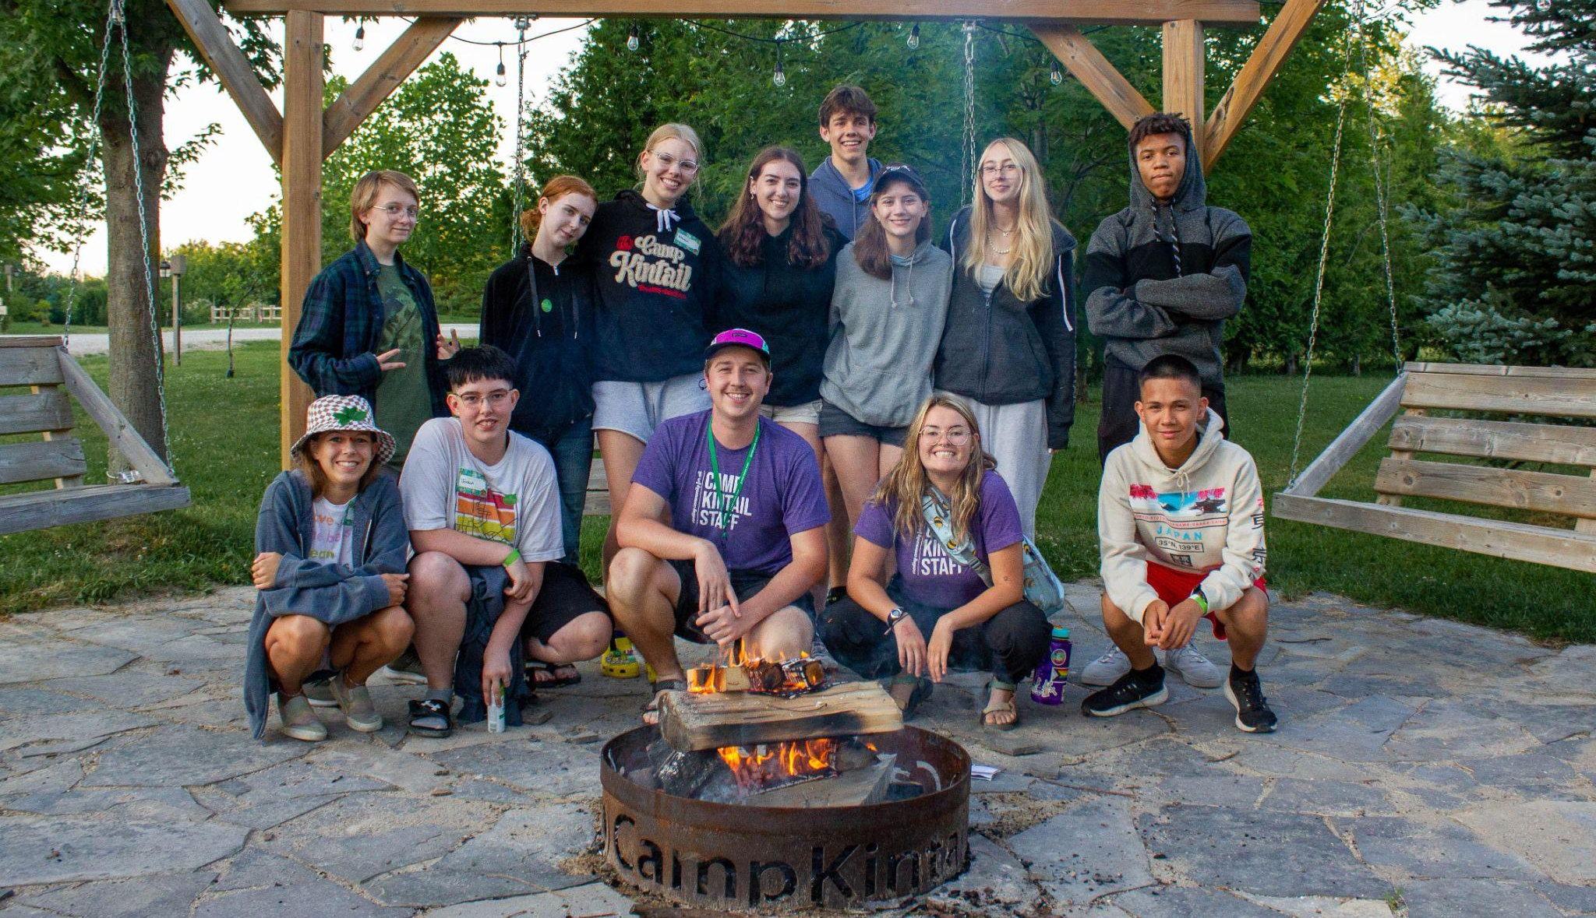

Leader in Training Program

LITs will come to Kintail for two weeks of the summer to live in community. They will live with their LIT Resource Counsellors in the Nest, spending time in sessions, on adventures, and creating memories. LITs are then able to return to camp for to volunteer and spend time learning from the Kintail Staff how to be a cabin counsellor or support staff member. LITs can choose from any of the sessions listed below throughout the summer for their volunteer weeks. LITs are able to stay the weekend if they are participating in the next week’s cabin session, if not, they must go home at the close of the session.
Throughout their time in cabins or working with the support staff, the LITs will participate in check-ins and sessions with the other LITs. They will lead a FLASH (Faith, Learning, and Sharing) session, run a campfire, prepare morning Chapel, lead a morning activity, and assist the cabin counselors. Every LIT is guaranteed two weeks of cabin/support experience and additional weeks may be possible.

LEADER IN TRAINING DATES
LITs in Community
LIT Volunteer Week Options

A Weekend Away

A Weekend Away includes all of your meals, private accommodation, space at the Kintail beach, fire pit access, beautiful hiking trails, high-speed wifi, parking and other amazing activities! Parents will be responsible for their children at all times. Additional activities may be offered by Kintail Staff at no extra cost. You are welcome to bring coolers with pop and peanut-free snacks, though coffee, tea, and juice will be available all day alongside a wonderful selection of pastries and fruit!

WHAT TO EXPECT
Delicious catering! | Amazing site! | Stress free vacation!
Assigned dining spaces  Red Seal Chef  All dietary needs accommodated | Free high-speed wifi  Private beach access  Programming & activities | COVID safety practices  Plenty of outdoor space  All activities optional

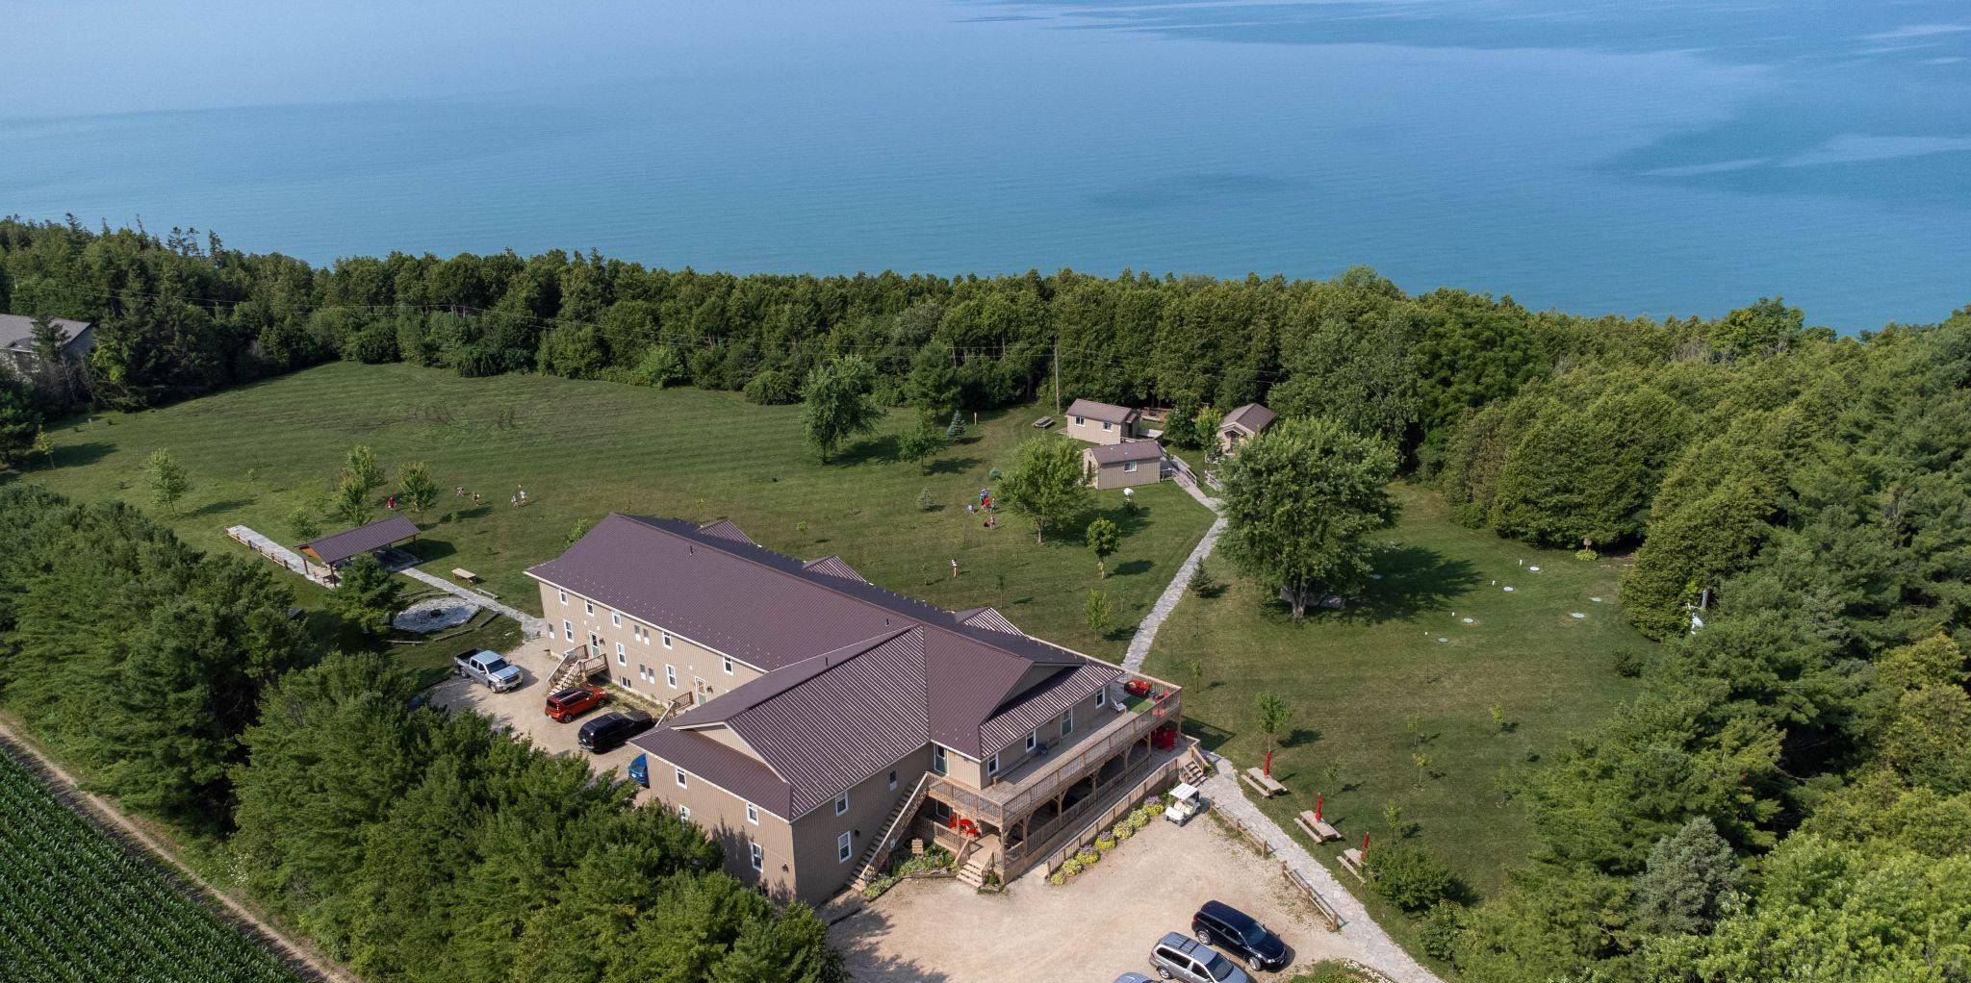
Family Camp

Family Camp is back! We have limited spaces available for friends of Kintail to join us for the long weekend this summer. The same delicious food and hospitality as in years past will greet you! Pricing for Family Camp will be the same as A Weekend Away, with variable prices depending on accommodation type (Nest or Cabin) as well as age (Adult or Child). All guests who visit Kintail will have similar activities offered to them, but Family Camp has extra emphasis on reliving a typical day as a camper with the whole family (FLASH, Chapel, Campfire, etc). You’ll love a weekend away OR family camp!

What session should I choose for my camper?

All campers who visit Kintail will get to enjoy the same core activities! Children will spend time every single day at the beach and will have opportunities to canoe, kayak, paddleboard, or corcl. Campers will all have the chance to participate in activities at the high challenge course (ages 7+), archery, slide, slingshot, arts and crafts, hiking, and so much more! The differences between the camps are often more to do with how a campers day is structured versus what happens within that day.

Kintail has options for teenagers and campers as young as 5!
SUMMER CAMP SESSION DESCRIPTIONS
Outdoor  Adventure | Located on the Kintail site, campers will stay in yurts or cabins. These campers will prepare one third of their meals over the fire and have another one third sent to their site from the kitchen. The remaining meals will take place in the MacDonald Lodge Dining Hall. ODA is a more relaxed,nature based camp. These sessions are perfect for campers who do well with a small group and love spending time in the woods.
Discovery Camp | Enjoy meals served at MacDonald Lodge while exploring all the fun activities camp has to offer. These campers will have opportunities to try out all of the fun programs at Kintail and rotate as a cabin to try a variety of programs with their counselors. A great all-around “classic summer camp” experience!
Volunteers of Kintail | Designed for high-school students, campers will get to participate in all of Kintail’s activities and programs while earning community service hours which count towards their high school diploma! They help with dishes after each meal but get a chance to enjoy the ropes course and go to the beach every day.
Pre-LIT | Pre-LITs will gain valuable skills relating to leadership at home, school, and in the community as well as ORCKA certification in flat-water canoeing. They will also learn about teamwork through games, initiatives, and activities. FLASH is a time of exploration of leaders from the Bible. This is sure to be an epic week of fun, friendship, and fostering new confidence and skills.

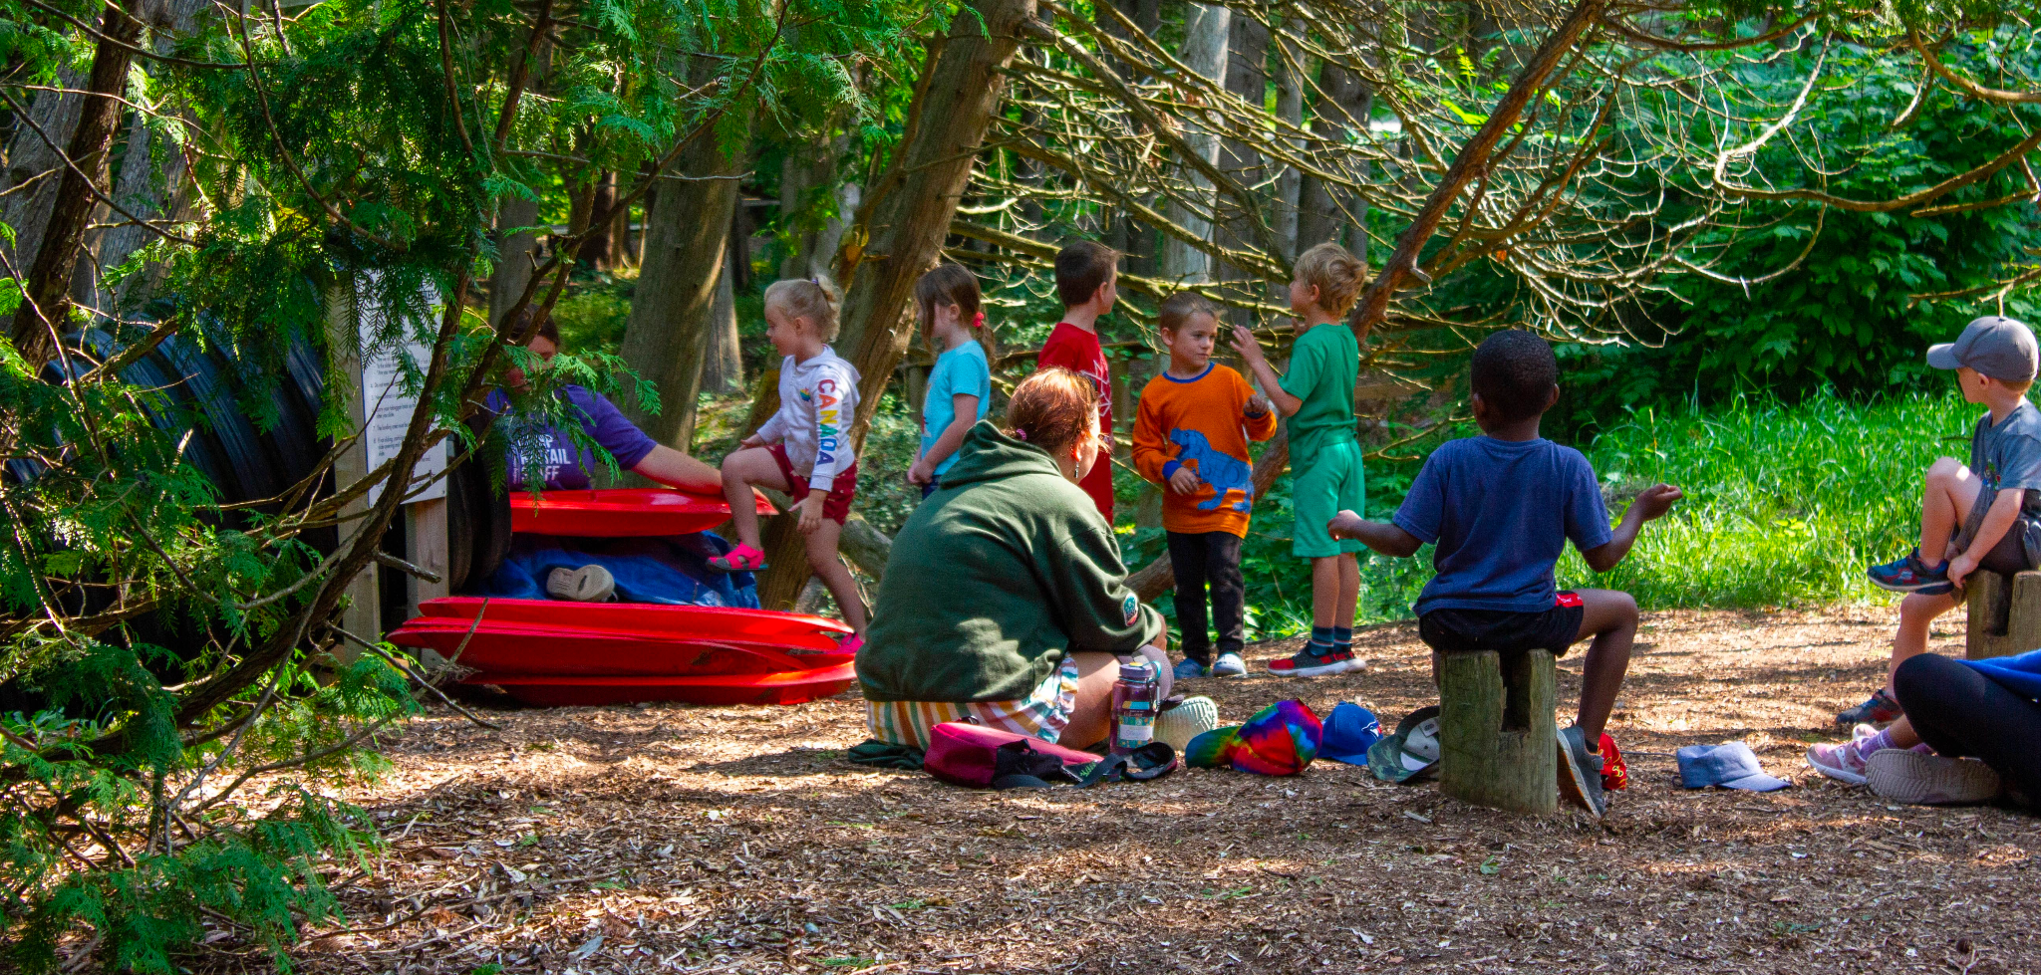
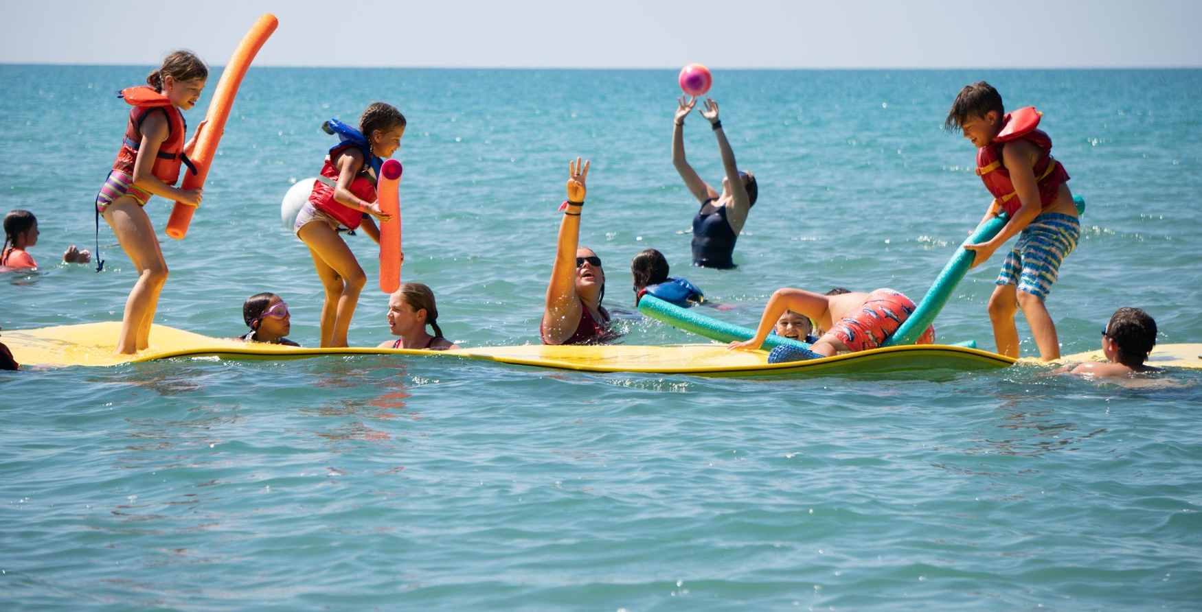
Day Camp Information

Camp Opening
Campers arrive at Camp Kintail each morning between 9:00am - 9:15am.

Camp Closing
Campers will be ready to go home at 4:30 pm each day.
*Photo ID will be required at pick-up every day, please ensure anyone picking up your camper is on the authorized pick-up list.

Catering
Lunch will be provided each day of day camp. It will be delicious and nutritious, and give day campers the same dining experience that overnight campers love.

Activities
Day Campers will enjoy all of the same activities as our overnight campers! They’ll spend time every day at the beach and enjoy other sessions (FLASH, archery, arts and crafts, high challenge for ages 7+, slide, slingshot, etc.) all while spending plenty of time outdoors!

Forms
The Health and Information Form has been completed through the online process. Please notify us of any changes on opening day.

Snacks
You are welcome to send snacks with your camper, please ensure they are nut free.
Kintail is a nut and allergy aware facility and we ask that you do not bring any snack items on site that contain any peanut or nut products.

Bus
There are no buses planned for Goderich or Kincardine at this time. Thank you for your understanding!

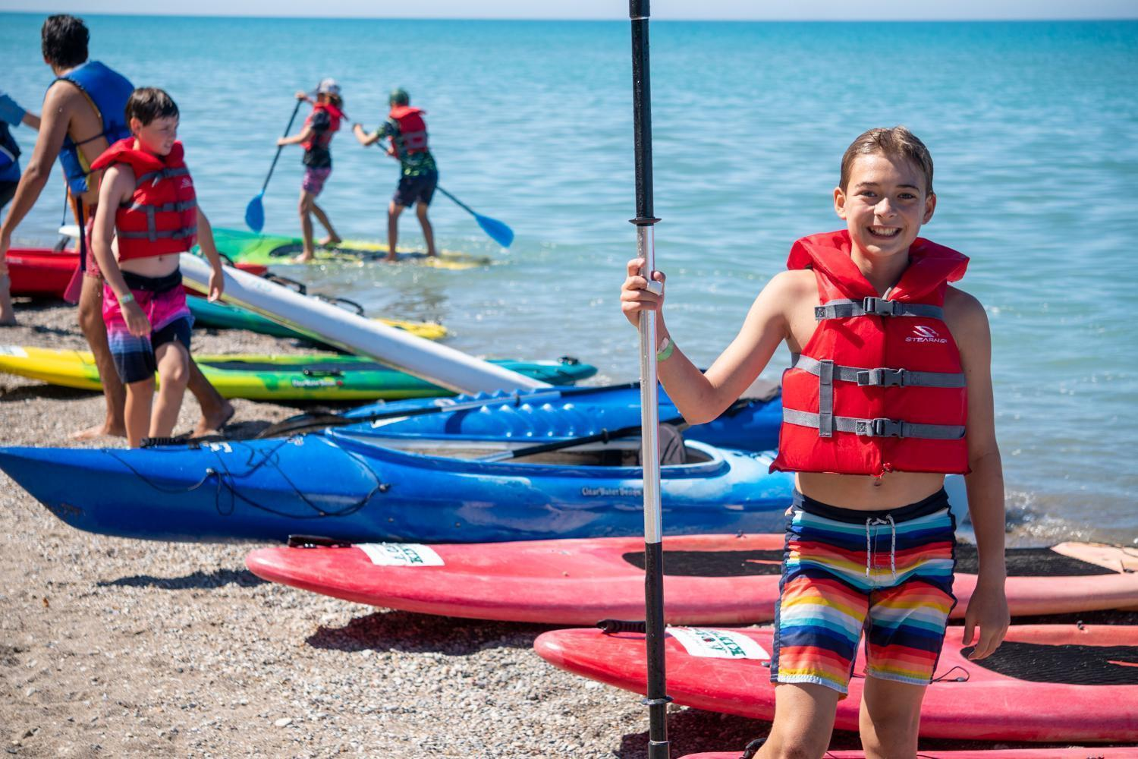

Meals and Dining

Food quantity and quality is our priority. Warm, fresh, and healthy food is what we want all of our guests to experience with their stay at Camp Kintail. Our professional kitchen staff provide nutritious and plentiful food for everyone to enjoy, with a careful crafted child-friendly menu for our campers. We are happy to accommodate any dietary restrictions upon request, and always have a full salad bar as well as bread, soy butter, and jam available if a camper would prefer a sandwich. Campers should talk to their counselors if there are not enough food options at a meal time to keep them full, and we will gladly help them and ensure they get enough food! Apples and bananas are available all day long.

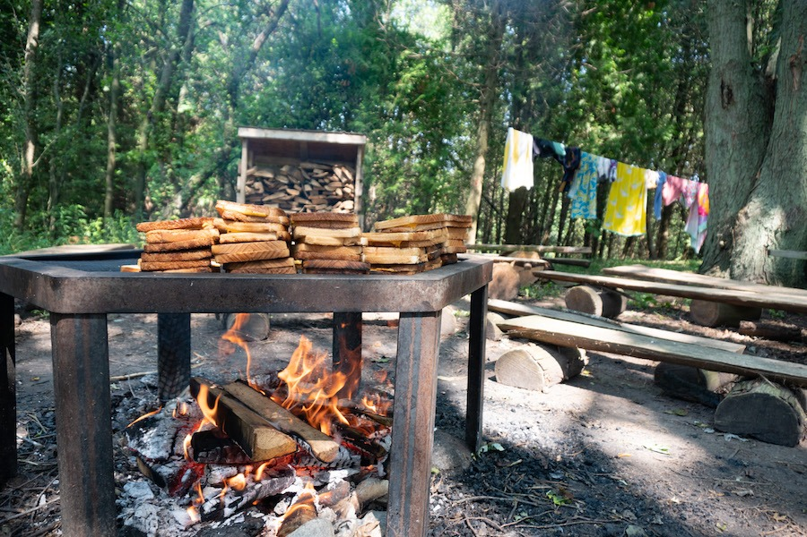

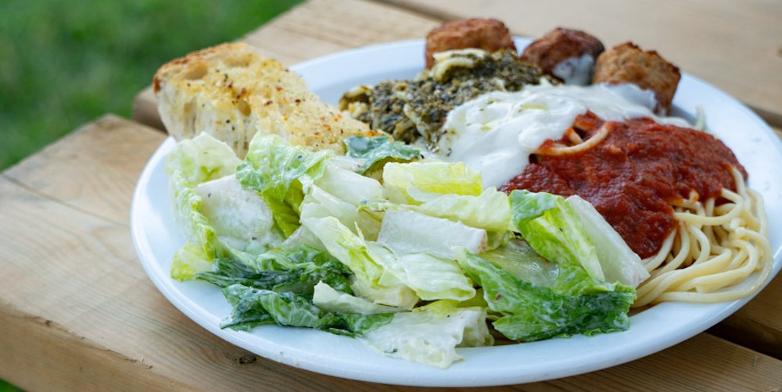

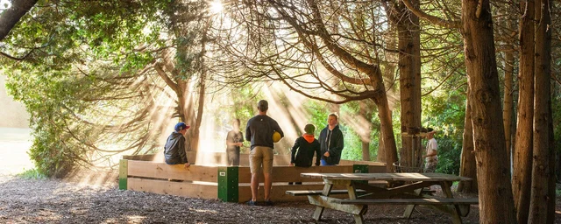
TYPICAL MEALS AT KINTAIL
Breakfast | Lunch | Dinner
Pancakes & Sausages  French Toast & Sausages  Pastries and Oatmeal  Eggs & Bacon | Hamburgers & Hotdogs  Sub Sandwiches & Chips  Tacos or Quesadillas  Chicken Caesar Wraps | Spaghetti & Meatballs  BBQ Chicken & Rice  Roast Beef & Potatoes  Chicken Burgers & Fries
All lunches and dinners include a large salad bar

What happens next

Step 1: Register
- When registration opens February 1, 2023 you can go online and register for your spot. No deposit is required.
- Receive your automated confirmation email which you can reply to with questions at any time. This email will include a confirmation package with some FAQs

Step 2: Get ready for camp
- Follow us on social media to see photos of the activities your camper will get to do, and have a chance to see what Kintail is like before they arrive!
- In the days before camp you’ll get an email recapping your account, important information for families, and a packing list.
- In the days before camp pending payments that have been set up will be processed

Step 3: Arrive at Kintail (3:00-4:00 your first day of camp)
- Drive down the lane and you’ll be greeted by a staff who will direct you for parking. Please do not drive on the grass. Then come to the gazebo where you will sign in your camper, and find out which cabin they will be in!
- Beside the gazebo is a table where the health care providers for the week will be available to have a conversation about your campers needs, and take all camper medication.
- Drop off your camper and put any letters you would like delivered into the bins labelled by day of the week

Step 4: Enjoy the week of camp
- While your camper is at Kintail you can follow our Facebook page to see photos of the activities happening that day

Step 5: Pick-up your camper (2:30 on the last day of camp)
- Bring your photo ID to the sign with your campers cabin name on it and sign out with their counsellors!
- Check the lost and found
- Pick up any medications and ask any questions with our health care team.

